

Practices for Secure Software Report

Table of Contents
Document Revision History 3
Client 3
Developer 4
1. Algorithm Cipher 4
2. Certificate Generation 4
3. Deploy Cipher 4
4. Secure Communications 4
5. Secondary Testing 4
6. Functional Testing 4
7. Summary 4
8. Industry Standard Best Practices 4

Document Revision History

Version | Date | Author | Comments
1.0 | 12/13/2025 | Cody Beck

Client



Developer
Cody Beck

Algorithm Cipher

SHA-256
- Cryptographic has function that takes any input data and produces a fixed-size hash value of 64 characters (256 bit).
- Computationally infeasible to reverse the process to get the original data.
- Even a small change to the input results in a completely different hash.
- The effort to find the original input from a given hash is 2 to the power of 256 or 256-bit security.
- Per NIST standards for SHA-256, the effort to find two different inputs that produce the same hash is about 2 to the power of 128 (128-bit security).

Random numbers are used to generate unpredictable keys which are harder to guess. A symmetric key is used both to encrypt and decrypt data. An asymmetric key is usually used for signing. A public key is generated from a trusted source and is used for verification before using the private key to decrypt the data. Older standards such as DES, developed by IBM in the 1970s, only used a 56-bit key. As computing power increased it made it possible to brute force these ciphers and left systems using them vulnerable to attack. Moving forward Public-Key Cryptography was introduced, an asymmetric encryption where a public key encrypts data and a private key decrypts it. Later in 2001 the Advanced Encryption Standard (AES) was selected by NIST. AES is a symmetric encryption algorithm that is the current global standard for securing data. This algorithm offers key sizes of 128, 198, and 256 bits. It is considered secure against all practical attacks.

Certificate Generation

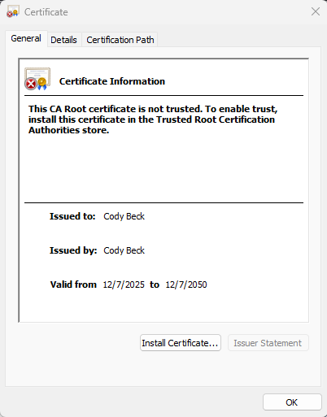

Deploy Cipher

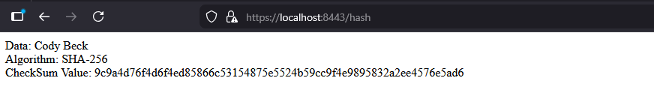
Please note the checksum value as proof that the algorithm is functional.

Secure Communications

Please note the web address containing https to show that SSL has been enabled.

Secondary Testing

Application running without errors:
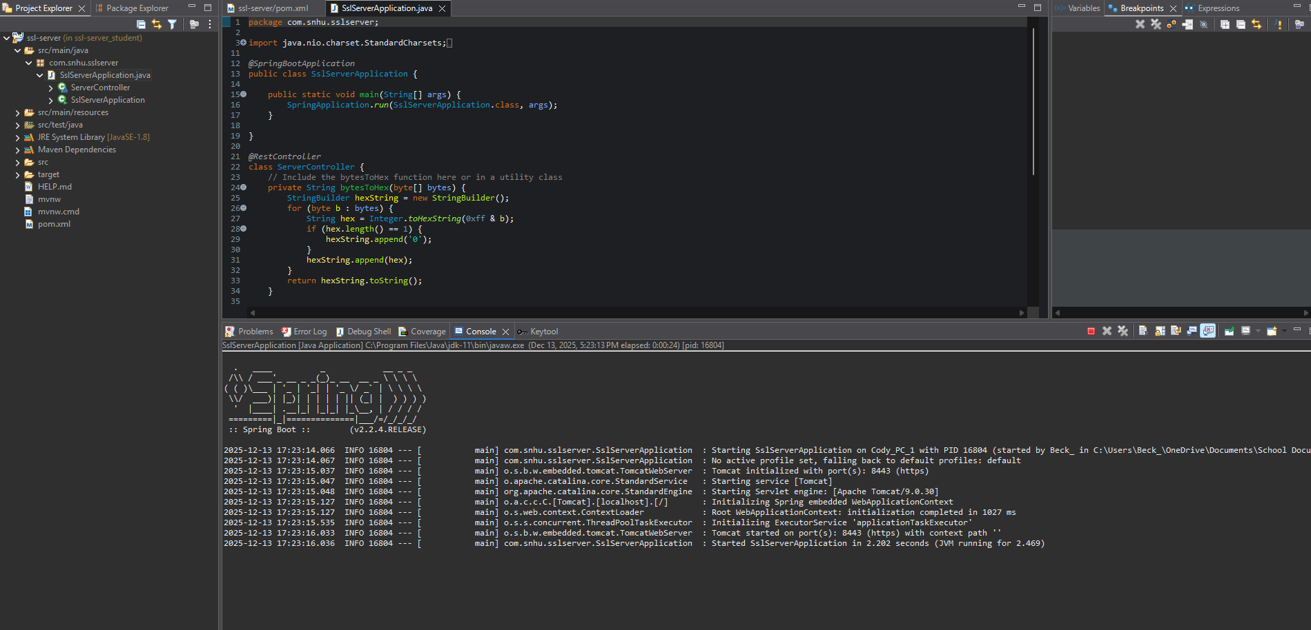

Dependency-check static testing:
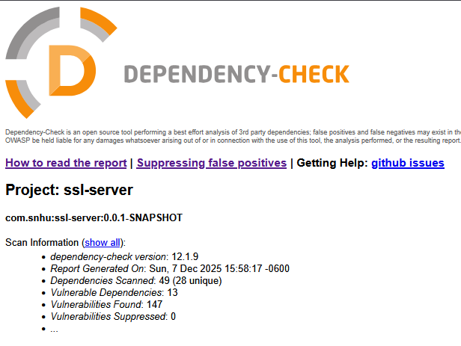

Functional Testing

Refactored code executed:
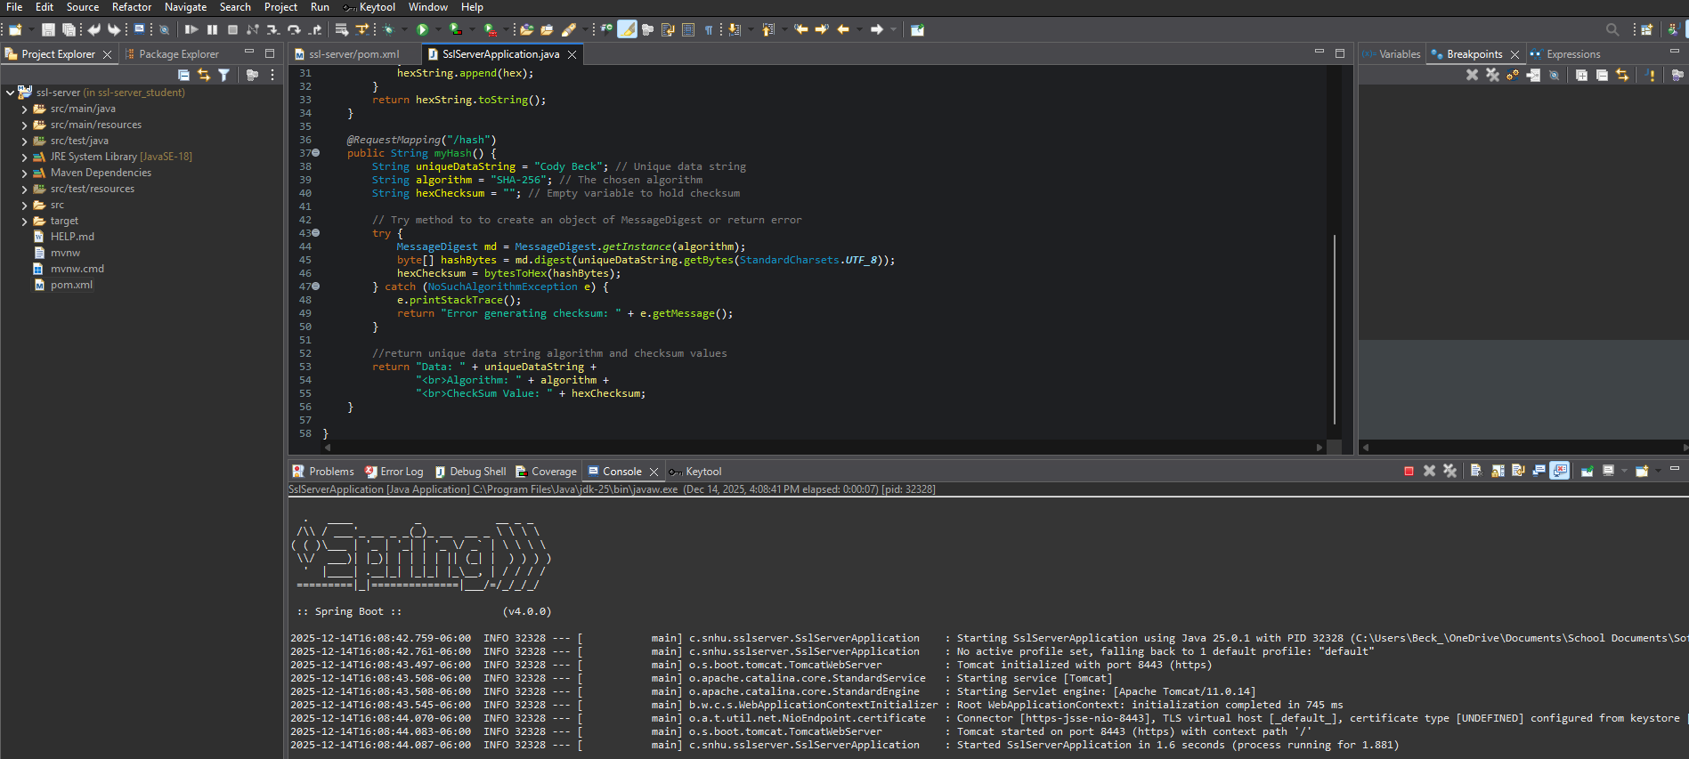

Refactored code static test:
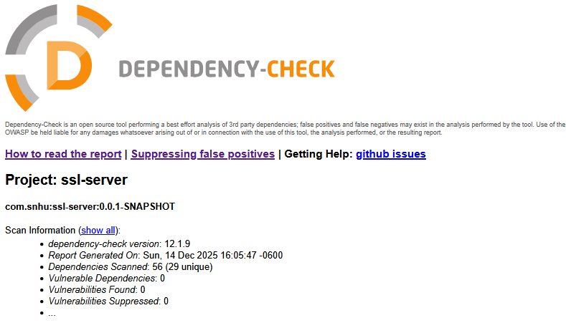

Summary

The code has been refactored according to the Vulnerability Assessment Process Flow diagram. This allows a step-by-step look into the structures of the software to ensure that all necessary security measures are taken in applicable fields. The points listed below have been revised as necessary.

- APIs: Ensured secure communication by utilizing certificates built using the secure algorithm SHA-256.

- Cryptography: Ensured the hashes from algorithm SHA-256 would not be able to be duplicated or have data extracted.

- Client/Server: Updated Spring framework to the latest compatible version (4.0.0) to ensure fixes and updates to security are present.

- Code Error: Ensured errors generated by added algorithm are handled in a manner that prevents exploitation.

- Code Quality: Updated Java version to JDK 18 (Java-25) to ensure compatibility with framework upgrade.

To add additional layers of security I first reviewed the existing code to determine what could be added. First an acceptable algorithm was chosen. During review of those available, SHA-256 was found to have the properties needed to secure an application involving personal data. This was used to build a hash to encode data transferred. Using Keytool I created a default certificate that enabled secure communication with the web service and the method for decryption. This was verified by showing the hash value of a unique string. In this case I used my name and verified that the hash contained 256-bits (64-characters).

Industry Standard Best Practices

To ensure industry standard best practices automated and manual scanning were integrated with all software development steps to ensure errors and regressions were caught early. Input validation is being handled by Jakarta Bean Validation. I used least privilege to ensure only those who needed access to complete tasks had it. Utilized generic error messages to avoid revealing system details. Software went through iterations with consistent testing. Updated frameworks and libraries to fix know vulnerabilities. I ensured that the encryption algorithm is robust enough to secure private information such as personal data and account information. Last but certainly not least is to build an incident response plan if data is leaked or hacked. This would include informing your customers/ members involved in the breach of what happened and what that data included.

